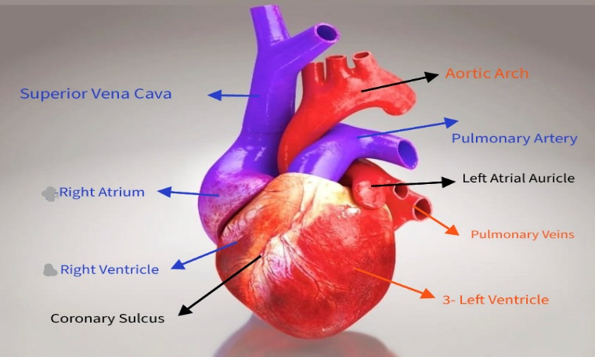

Pic 1:
- Superior Vena Cava: (SVC)
  - is a large, valveless vein that returns deoxygenated blood from the upper half of the body to the right atrium of the heart.
  - centimeters long and 2 centimeters in diameter.
  - located in the anterior right superior mediastinum.
  - It is formed by the union of the left and right brachiocephalic veins.
  - terminates in the upper part of the right atrium.
- Right Atrium:
  - is the heart’s upper-right chamber that receives deoxygenated blood from the body and directs it to the right ventricle through the tricuspid valve.
  - forms the right border of the heart in the mediastinum.
  - thin-walled, low-pressure chamber.
  - receives blood from the superior vena cava (SVC), inferior vena cava (IVC), and coronary sinus.
- Right Ventricle:
  - is the heart chamber responsible for pumping deoxygenated blood to the lungs for oxygenation through the pulmonary valve into the pulmonary artery, directing it to the lungs for oxygenation.
  - with walls thinner than the left ventricle (about 3–5 mm) because it pumps blood a shorter distance at lower pressure.

- Coronary Sulcus:
  - Also known as the atrioventricular groove.
  - Is a shallow groove on the heart’s surface that separates the atria from the ventricles and contains major coronary vessels.
- Aortic Arch:
  - is the curved portion of the aorta that connects the ascending and descending aorta, distributing oxygen-rich blood to the head, neck, and upper limbs.
  - beginning at the level of the second sternocostal joint and extending to the fourth thoracic vertebra (T4).
  - It curves posteriorly and to the left.
  - gives rise to three major arteries: Brachiocephalic trunk, Left common carotid artery & Left subclavian artery.
- Pulmonary Artery:
  - is a blood vessel that carries deoxygenated blood from the right side of the heart to the lungs for oxygenation.
  - Originate from right ventricle of the heart & branches into right and left pulmonary arteries.
- Left Atrial Auricle:
  - also known as the left atrial appendage (LAA).
  - flap or thin pouch of the heart wall located on the anterior surface of the left atrium.
  - It is remanent of fetal left heart.
- Pulmonary Veins:
  - are blood vessels that carry oxygen-rich blood from the lungs to the left atrium of the heart.
  - The only veins in the body that carry oxygen-rich blood.
  - are part of the pulmonary circulation.
  - Most people have four pulmonary veins, two from each lung (superior & inferior)
  - These veins originate in the lungs at the hilum pass through the posterior mediastinum and empty into the left atrium of the heart.
- Left Ventricle:
  - is the heart’s lower left chamber responsible for pumping oxygenated blood to the entire body.
  - forming the heart’s apex.
  - contributing to the anterior, diaphragmatic, and apex surfaces of the heart.
  - has the thickest myocardium of all heart chambers.
  - Two key valves regulate blood flow in and out of the left ventricle: Mitral (bicuspid) valve: Located between the left atrium and left ventricle & Aortic valve: Situated at the opening to the aorta.

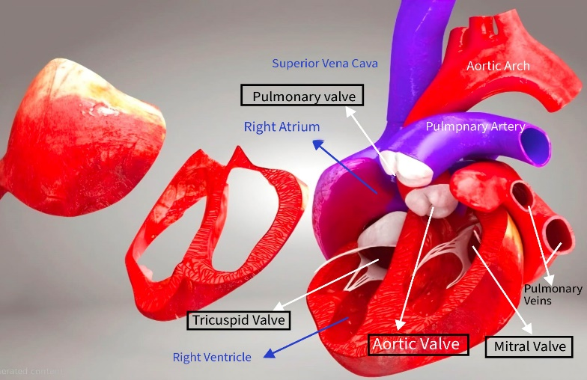

Pic 2:
- Superior Vena Cava:
- Pulmonary Valve:
  - is a semilunar heart valve that controls blood flow from the right ventricle to the pulmonary artery, ensuring blood moves toward the lungs without backflow.
  - consists of three crescent-shaped cusps or leaflets—commonly named right, left, and anterior.
- Right Atrium:
- Tricuspid Valve:
  - s a one-way heart valve that controls blood flow from the right atrium to the right ventricle and prevents backflow.
  - has three leaflets or cusps—anterior, posterior, and septal—that open and close with each heartbeat.
  - These leaflets are anchored by chordae tendineae to the papillary muscles of the right ventricle, which prevent the valve from inverting during ventricular contraction.
- Right Ventricle:
- Aortic Arch:
- Pulmonary Artery:
- Pulmonary Veins:
- Mitral Valve:
  - s a heart valve located between the left atrium and left ventricle that ensures one-way blood flow from the atrium to the ventricle.
  - It is a bicuspid valve as it has two leaflets (cusps): an anterior and a posterior leaflet.
- Aortic Valve:
  - is a heart valve that controls blood flow from the left ventricle into the aorta, ensuring one-way circulation to the body.
  - It is semilunar valve, named for the crescent-shaped flaps, or cusps, that make up the valve
  - This opening and closing mechanism contribute to the second heart sound (S2) heard during a heartbeat.
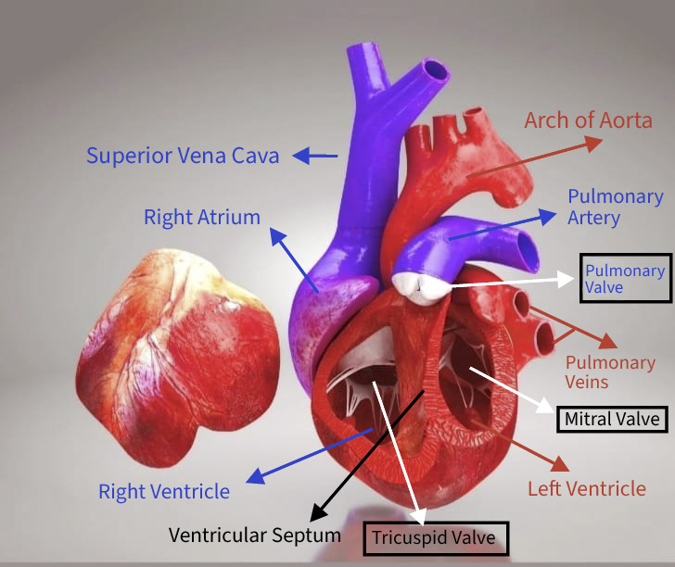

Pic 3:
- Superior Vena Cava:
- Right Atrium:
- Right Ventricle:
- Ventricular Septum (interventricular septum):
  - is the wall of tissue that separates the left and right ventricles of the heart, ensuring proper blood flow and supporting cardiac function.
  - It consists of two main parts:
    - Muscular portion: The larger, thick part forming most of the septum.
    - Membranous portion: A smaller, thin, fibrous section near the upper part of the heart, close to the aorta (more prone to congenital defects).
- Tricuspid Valve:
- Left Ventricle:
- Mitral Valve:
- Aortic Arch:
- Pulmonary Artery:
- Pulmonary Veins:
- Pulmonary Valve:

------------------------------------------------------------------------------------------------------------------------------------------------

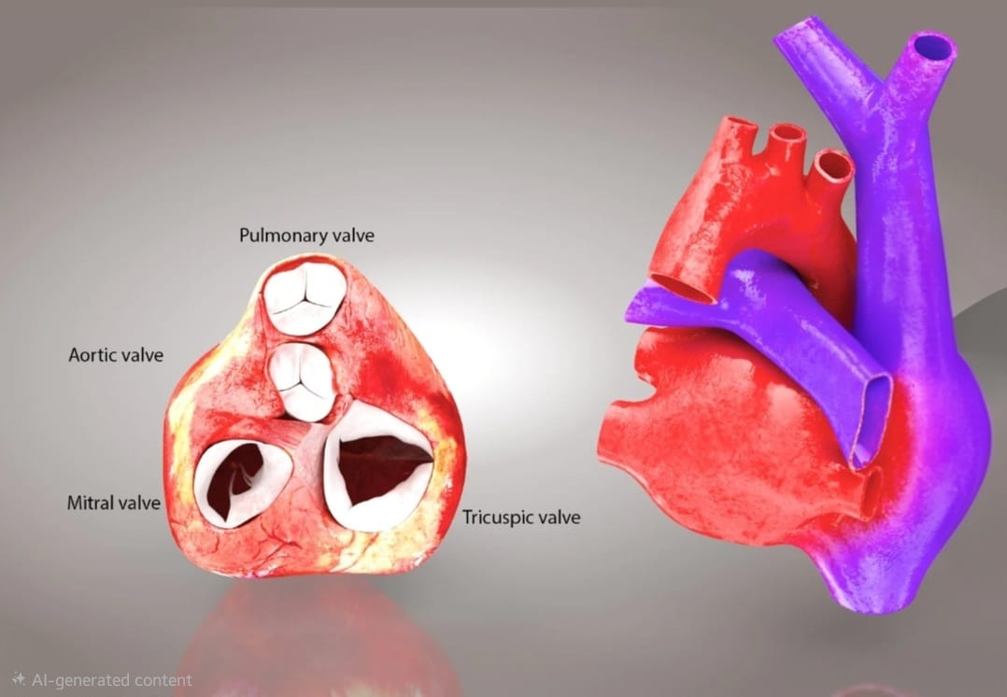

Pic 4:
- Pulmonary Valve:
- Aortic Valve:
- Mitral Valve:
- Tricuspid Valve:

------------------------------------------------------------------------------------------------------------------------------------------------

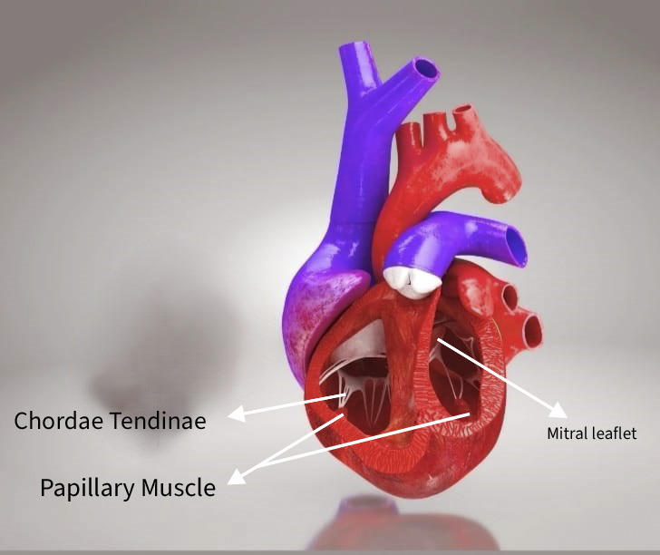

Pic 5:
- Mitral leaflet:
  - are the two flaps of the mitral valve that regulate blood flow from the left atrium to the left ventricle, ensuring one-way circulation and preventing backflow.
  - The mitral valve consists of two leaflets: the anterior leaflet and the posterior leaflet.
  - connected to papillary muscles via chordae tendineae, which prevent prolapse during ventricular contraction.

- Chordae Tendinae:
  - are inelastic cords of fibrous connective tissue that connect the papillary muscles to the atrioventricular valves(tricuspid valve and the mitral valve).
  - Their primary function is to prevent the inverting of the heart valves during ventricular contraction ensuring that blood flows in One Direction & prevents the backflow of blood from the ventricles back into the atria.
  - It also Prevent Valve Prolapse of the atrioventricular valve leaflets into the atrial chambers during systole.
- Papillary Muscles:
  - They are conical structures located in the ventricles of the heart that play a crucial role in preventing the prolapse of atrioventricular valves during ventricular contraction.
  - They are found within the ventricles of the heart, specifically attached to the mitral valve (left ventricle) and the tricuspid valve (right ventricle) via chordae tendineae.
------------------------------------------------------------------------------------------------------------------------------------------------
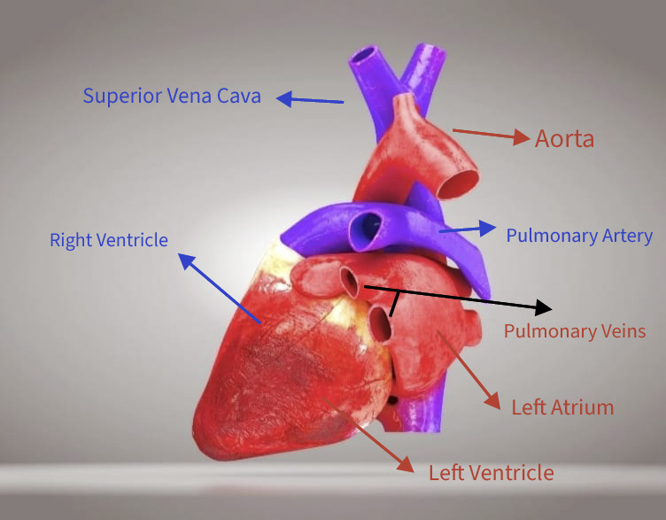

Pic 6:
- Superior Vena Cava:
- Right Ventricle:
- Left Ventricle:
- Left Atrium:
- Aorta:
- Pulmonary Artery:
- Pulmonary Veins:

